Chapter 3 Question 16 - Michael Streyle

##   
## Call:  
## lm(formula = concentration ~ time)  
##   
## Residuals:  
## Min 1Q Median 3Q Max   
## -0.5333 -0.4043 -0.1373 0.4157 0.8487   
##   
## Coefficients:  
## Estimate Std. Error t value Pr(>|t|)   
## (Intercept) 2.5753 0.2487 10.354 1.20e-07 ***  
## time -0.3240 0.0433 -7.483 4.61e-06 ***  
## ---  
## Signif. codes: 0 '***' 0.001 '**' 0.01 '*' 0.05 '.' 0.1 ' ' 1  
##   
## Residual standard error: 0.4743 on 13 degrees of freedom  
## Multiple R-squared: 0.8116, Adjusted R-squared: 0.7971   
## F-statistic: 55.99 on 1 and 13 DF, p-value: 4.611e-06

## (Intercept) time   
## 2.575333 -0.324000

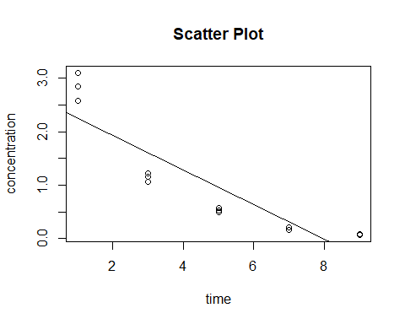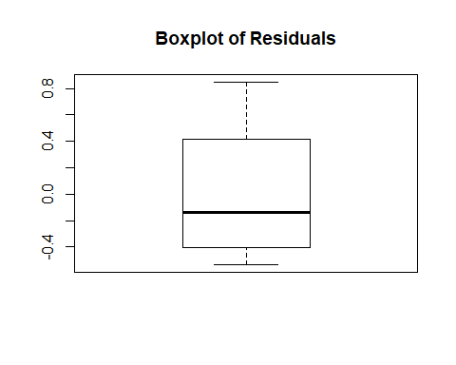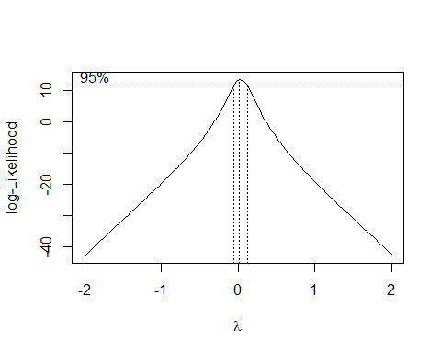

## (Intercept) time   
## 0.6548798 -0.1954003

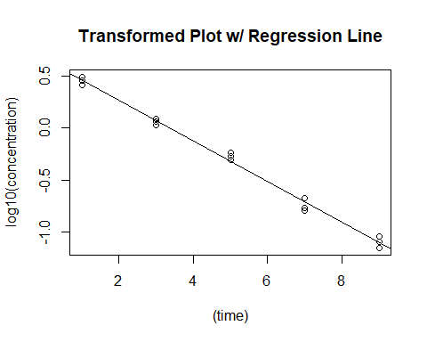

## 1 2 3 4 5   
## -0.051178946 0.057965523 0.006813001 -0.082957620 -0.056628681   
## 6 7 8 9 10   
## 0.035141692 0.012317861 0.085549775 0.046397651 0.017680995   
## 11 12 13 14 15   
## -0.007980995 -0.039295058 -0.006161112 -0.049546328 0.031882242

